**Definition of a Dimension**

In a *d* – dimensional space, the volume $V$ of a ball of radius $R$ grows like $R^{d}$, hence the following heuristic for dimension is obtained:

$$d≈\frac{logV}{logR}$$

Some other properties that good definitions of dimensions should have are the following:

1. **Monotonicity $A⊂B⇒dimA≤dimB$**
2. **Stability $dim\left(A∪B\right)=max(dimA,dimB)$**
3. **Countable Sets $If A is countable or finite, dimA=0$**
4. **Geometric Invariance $dimA=dimB for any affine transformation$**

**Minkowski Dimension**

This definition of dimension is a method of determining fractal dimension of a set *S* in $R^{n}$.

Suppose the set *S* is placed on a grid of boxes with side length $ϵ$. Then, the Minkowski Dimension of *S* is:

$$\dim{S= \lim_{ϵ→0}{\frac{\log{N(ϵ)}}{\log{(1/ϵ)}}}}$$

where $N(ϵ)$ is the number of boxes needed to cover the set. When the limit doesn’t exist, the limit superior and limit inferior are used to define upper and lower Minkowski dimension.

**The Algorithm**

Using Minkowski Dimension we tried to estimate the fractal dimension of the Weierstrass function, for particular values of *a* and *b*. We used

$$f\left(x\right)=\sum_{i=0}^{N}{a^{i}cos⁡(2πb^{i}x)}$$

as an approximation of the function, and sampled a total of *n* points of the function on the interval $[0,1]$.

The procedure was as follows:

1. Fix *n* , *N.*
2. Compute $f\left(\frac{i}{n}\right) , i=0,1,…,n$
3. Compute $\left( \left\lfloor \frac{i}{n}⋅M\right\rfloor , \left\lfloor f\left(\frac{i}{n}\right)⋅M\right\rfloor \right), i=0,1,…,n$
4. Find $N_{M}≔\# of unique pairs$

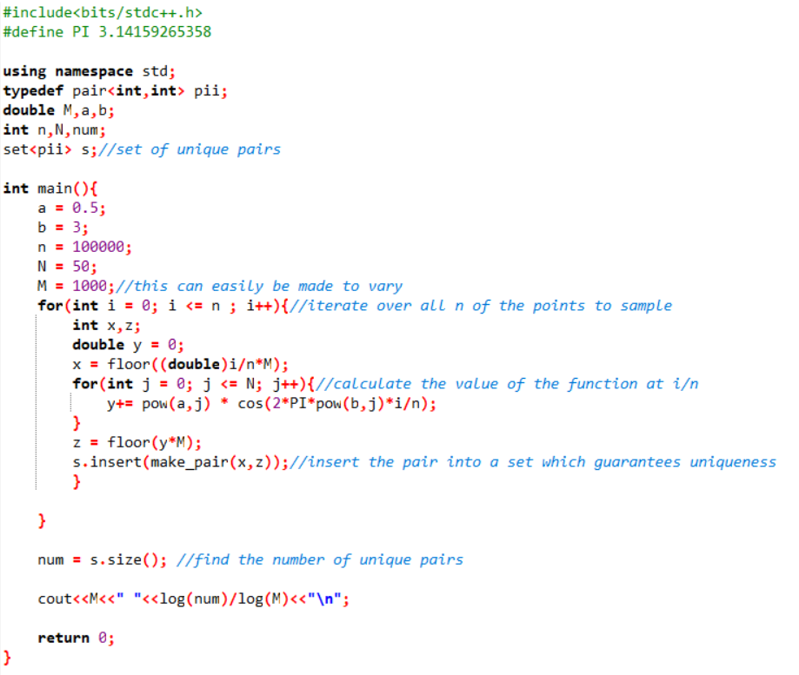Example C++ Implementation:

Sources

“Minkowski–Bouligand Dimension.” Wikipedia, Wikimedia Foundation, 10 Apr. 2018, en.wikipedia.org/wiki/Minkowski%E2%80%93Bouligand_dimension.

Pearse, Erin. “AN INTRODUCTION TO DIMENSION THEORY AND FRACTAL GEOMETRY: FRACTAL DIMENSIONS AND MEASURES.” AN INTRODUCTION TO DIMENSION THEORY AND FRACTAL GEOMETRY: FRACTAL DIMENSIONS AND MEASURES.

Tao, Terence. An Epsilon of Room. Pages from Year Three of a Mathematical Blog. American Mathematical Society, 2010.

**Results**

In order to estimate the Minkowski dimension, we graphed $M$ vs. $\log\left(N_{M}\right)/log⁡(M)$ (dimension). The results are shown in the two graphs below. In figure 1, the theoretical dimension is 1.37 and in figure 2 it is 1.50. The approximations were close but did not seem to converge to the theoretical value. (For all calculations N = 50).

Another approach we tried was varying the number of sampled points *n*, while fixing a grid size based on *n*.

|  |  |  |
| --- | --- | --- |
|  | Dimension |  |
| *n* | *a = 0.5, b = 3*  *(theoretical value 1.37)* |  |
| 100000 | 1.7537 |  |
| 1000000 | 1.6924 |  |
| 10000000 | 1.6455 |  |

This approach tends to overshoot dimension so it’s possible that larger values of *n*, will yield better estimations. However, testing larger *n* was not possible due to the time complexity of the algorithm.

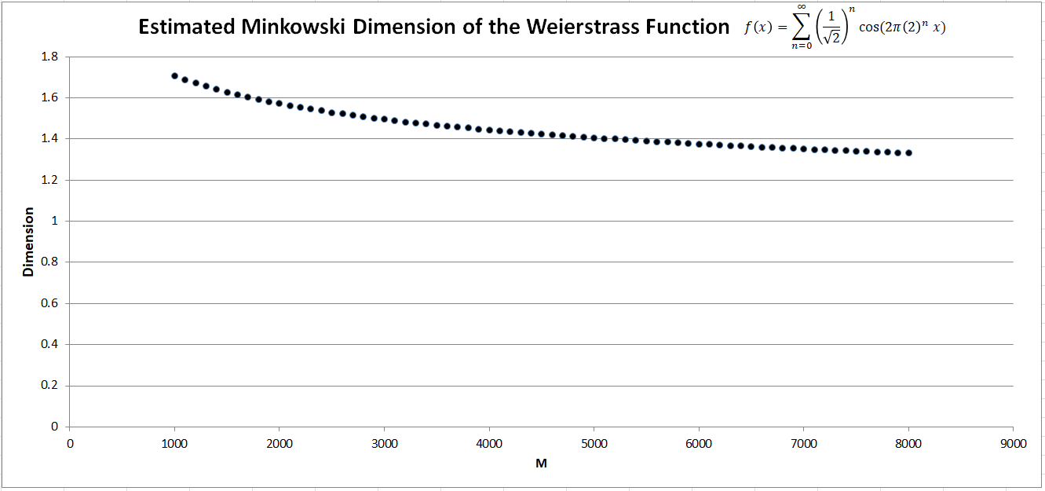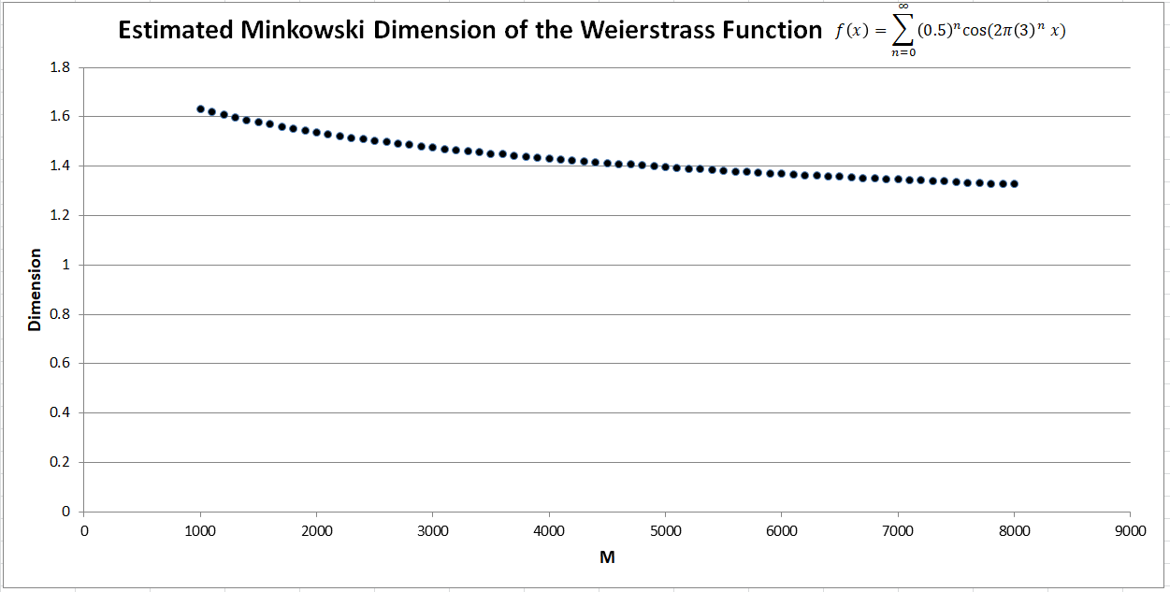

Figure 2

Figure 1